Mohaned Khaled ElDeeb

Class E

221011513

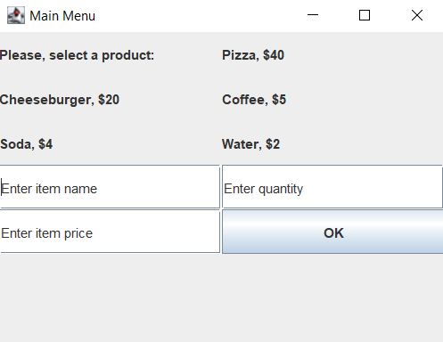

First time running

Entering dummy values then clicking OK

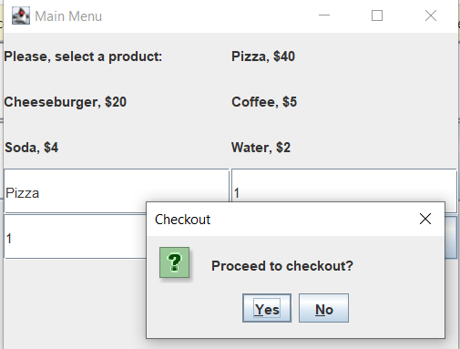

Clicking NO will make us enter new items (max 10 for the shopping cart limit)

Clicking YES:  
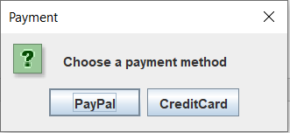  
Choosing PayPal:  
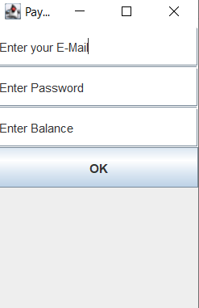

Entering Correct Credentials:  
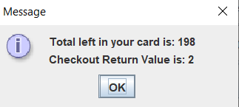  
Entering Wrong Credentials:  
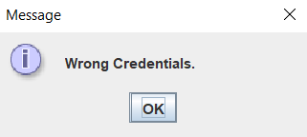

Choosing Credit Card:

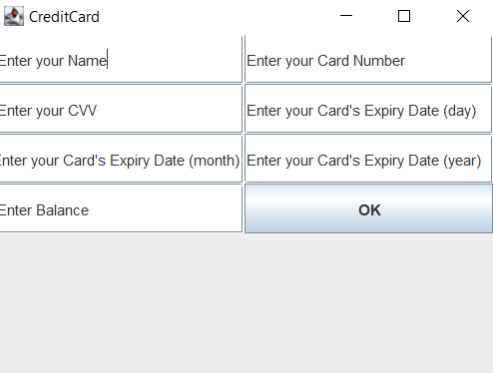  
Card Not Expired:  
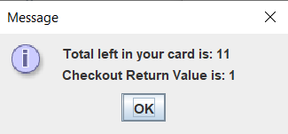  
Card Expired:

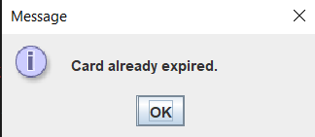

UML:

